**MapReduce WordCount with PIG in AWS**

1. Write a PIG script for MapReduce WordCount



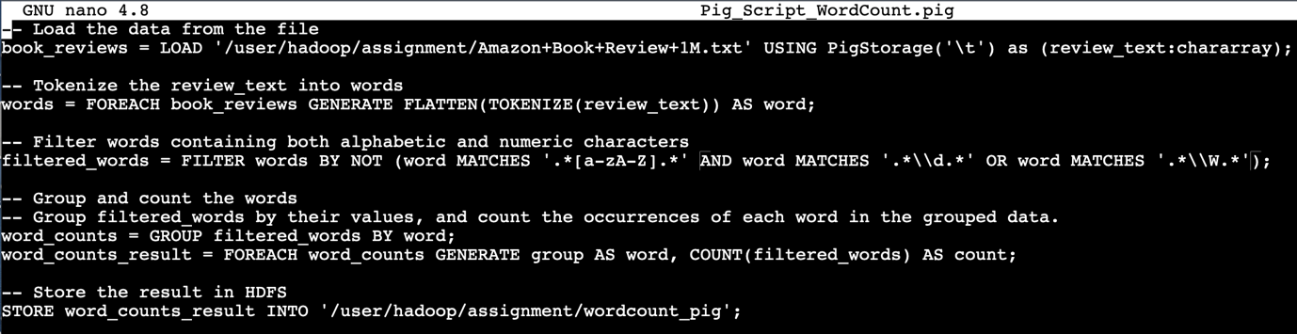

1. Run the PIG script Command





1. The output of WordCount with the PIG script

